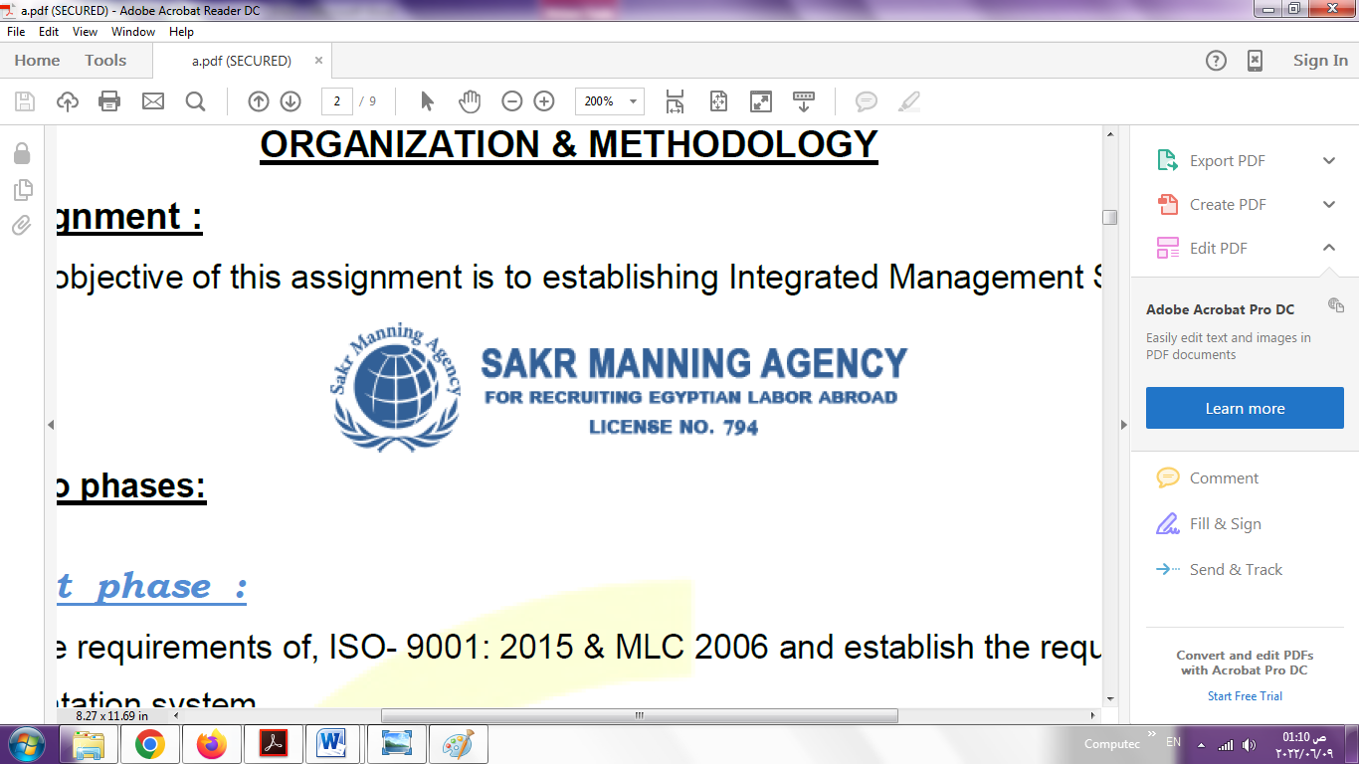 | SAKR MANNING AGENCY  FOR RECRUITING EGYPTIAN LABOR ABROAD | Issue Date | 15.05.2022
 |  | Revision Date | 19.07.2022
 | Crewing Management Manual  Seafarer Employment Application | Revision | 1.1
 |  | Page | 3

Application For Position as | oiler
Register Code. | ER-3.063
Other Position (If Any)
Register Date | 29/04/2023
Last up Date Data | 29/04/2023
Expected Salary | 800 U.S.D

1. PERSONAL DETAILS
Full Name |  | ahmed mohamed ahmed elmahdy
Date Of Birth |  | 19/06/1992 |  |  |  |  |  |  | Place Of Birth |  |  |  |  |  |  |  | alexandria - egypt
Nationality |  | egyptian |  |  |  |  |  |  | Marital Status |  |  |  |  |  |  |  | Single ☐ |  |  |  |  |  |  |  | Married ☐yes
Height (Cm) |  | 169 cm |  |  |  |  |  |  | Overall Size |  |  |  |  |  |  |  | large 42 |  |  |  |  | Shirt Size |  |  |  |  |  | 42 large
Weight (Kg) |  | 72 kg |  |  |  |  |  |  | Trouser Size |  |  |  |  |  |  |  | 33 |  |  |  |  | Shoes Size |  |  |  |  |  | 42
2. EDUCATION
College / School |  | .INDUSTRIAL TECHNICAL INSTITUTE FOR MARINE ESTABILISHMENT DEPARTMENT OF PRODUCTION AND SHIP BUILDING –PORT SAID – EGYPT
Marline Test |  | Issued Date |  |  |  |  | Result % |  |  |  | Issued By (Authority) |  |  |  |  |  |  |  |  |  | Issued At
English Language |  | Fluent ☐ |  |  |  |  |  | Good yes ☐ |  |  |  |  | Average ☐ |  |  |  |  |  |  |  | Poor ☐
……… Language  ( arabic ) |  | Fluent yes ☐ |  |  |  |  |  | Good ☐ |  |  |  |  | Average ☐ |  |  |  |  |  |  |  | Poor ☐
3. CONTACT DETAILS
Home Address / City |  |  | 55 mortada.st alexandria - egypt
E-Mail |  |  | ahmednavygatur@gmail.com |  |  |  |  |  |  | Mobile / Tel |  |  |  |  |  | 0201063788079

4. TRAVEL DOCUMENTS
Type |  | Document No. |  |  |  | ISS. Date |  |  | Exp. Date |  |  |  |  | ISS. By (Authority) |  |  |  |  |  |  |  |  |  | Place of Issue
Passport |  | A29486238 |  |  |  | 2021 |  |  | 2028 |  |  |  |  | Egyptian Authority |  |  |  |  |  |  |  |  |  | ALEX
Seaman Book |  | 187466 |  |  |  | 2018 |  |  | 11/23 |  |  |  |  | EAMS |  |  |  |  |  |  |  |  |  | Alex.
Other Seaman Book

5. PROFESSIONAL QUALIFICATION / CERTIFICATE OF COMPETENCY
Certificate Name |  |  |  |  | Number | Issue Date |  |  |  |  |  | Expiry Date |  |  |  |  |  | Issued By |  |  |  |  |  |  |  |  | Issued At
COC |  |  |  |  |  |  |  |  |  |  |  |  |  |  |  |  |  | EAMS |  |  |  |  |  |  |  |  | Alex.
GOC |  |  |  |  |  |  |  |  |  |  |  |  |  |  |  |  |  | NTRA |  |  |  |  |  |  |  |  | Cairo
D.P. INDUCTION
D.P. ADVANCED
D.P. OPERATOR (UNLIMITED)
6. NEXT OF KIN
Full Name | YASMINE ADEL GOUDA |  |  |  |  |  |  |  |  |  |  |  |  |  | Relationship |  |  |  |  | WIFE
Address | 55 MORTADA .ST ALEXANDRIA - EGYPT
Tel. No. | 0203 576 1205 |  |  |  |  |  |  |  |  | Mobile |  |  | 0201062539012
7. HEALTH CERTIFICATES & VACCINATIONS
Flag State |  |  |  | Number |  |  | Issue Date |  |  |  |  | Expiry Date |  |  |  |  |  |  | Issued By |  |  |  |  |  |  | Issued At
International Medical |  |  |  | 0087074 |  |  | 21/02/2021 |  |  |  |  | EXTRACTION IS IN PROGRESS |  |  |  |  |  |  | EAMS |  |  |  |  |  |  | Alex.
Yellow Fever |  |  |  |  |  |  | 2/5/2014 |  |  |  |  | VAILD |  |  |  |  |  |  | Ministry of Health |  |  |  |  |  |  | ALEX
Cholera |  |  |  |  |  |  |  |  |  |  |  |  |  |  |  |  |  |  | Ministry of Health
Covid-19 |  |  |  | Vaccination Name |  |  | First Dose |  |  |  |  | Second Dose |  |  |  |  |  |  | (Other Does or Remarks)
 |  |  |  | johnson and johnson |  |  | 8-12-2021

8. MARINE COURSES
Course Name | Number | Issue Date | Expiry Date | Issued By / At
Personal Survival Techniques | 14248/19/EG | 11/4/2019 | 3/4/2024 | ARAB ACADEMY
Proficiency In Personal Survival Techniques
Fire Prevention and Fire Fighting | 14248/19/EG |  | 3/4/2024 | ARAB ACADEMY
Advanced Fire Prevention and Fire Fighting
Elementary First Aid | 14248/19/EG |  | 3/4/2024 | ARAB ACADEMY
Medical Care Studies
Personal Safety and Social Responsibilities | 14248/19/EG |  | 3/4/2024 | ARAB ACADEMY
Proficiency Of Security Awareness Training Seafarers | NR 2494951 | 19/12/2021 | 14/12/2026 | ARAB ACADEMY
Proficiency as a ship Security officer ( PSSO )
Proficiency In Survival Craft & Rescue Boats | NR 2494936 | 19/12/2021 | 14/12/2026 | ARAB ACADEMY
G.M.D.S.S
ENGINE ROOM WATCH ON SEAGOING VESSLS | 0005109 | 15/1/2017 | XXXXX | EAMS / ALEX
ENGINEERING WATCHKEEPING | 59689/16/EG | 21/12/2016 | XXXXX | ARAB ACADEMY
PROFICIENCY IN SURVIVAL CRAFT AND RESCUE BOATS | 02623 | 20/1/2022 | 25/11/2023 | EAMS / ALEX
Communications
Advanced Communications
ECDIS Advanced Simulator (Management Level)
ECDIS Simulator (Operation Level)
Prevention and Combating of Marine Pollution
Radar & ARPA Simulator and Search &rescue
ARPA Simulator and Search
Marine Radar and automatic Radar Plotting
Bridge resource Management (B.R.M)
Engine resource Management (E.R.M)
Navigational Watch keeping
Proficiency for Rating forming part of Navigational watch (II/4) |  |  |  | EAMS / Alex.
High voltage training – operation of ship (1000 Volt and More)
Passenger Safety Cargo Safety and Hull integrity
Crowd Management Training
Crisis Management and Human Behavior Training
Safety training for Personal Prov. Direct Passengers
Practical Ability to Prepare Meals and (MLC 2006)
Personal Hygiene and Envir. Protection (MLC 2006)
Safety and Health in the Provision Meals (MLC 2006)
Food Storage and inventory Control (MLC 2006)
Ships Cook Certificate (MLC 2006) |  |  |  | EAMS / Alex.
Abel Seafarer Deck
Proficiency for Abel Seafarer Deck ( II/5 ) |  |  |  | EAMS / Alex.
Engineering Watch keeping |  |  |  | EAMS / Alex.
Proficiency for Rating forming part of a watch in engine room
Abel Seafarer Engine
Proficiency for Abel Seafarer Engine ( III/5 ) |  |  |  | EAMS / Alex.
Electro Technical Rating
Proficiency for Electro Technical rating ( III/7 ) |  |  |  | EAMS / Alex.

COMPLETE SEA – SERVICE DETAILS

Name: | ahmed mohamed ahmed elmahdy |  |  |  |  |  |  | Rank: |  |  | asst.mechanic |  |  |  |  | Register Code: 1 No
Company Name |  |  | Rank |  | Vessel Name |  |  |  | Signed On |  |  | Signed Off |  |  |  | Period |  |  | Vessel Type |  | D.W.T. |  |  |  |  | Engine Type |  |  | BH | KW
NMDC |  |  | MECHANIC |  | SURVEY 1 |  |  |  | 30/7/2022 |  |  | 28/2/2023 |  |  |  |  |  |  | SURVEY |  | 24 TON |  |  |  |  | CAT 3304 4 STROKE |  |  | 250
TRIUMPH |  |  | MECHANIC |  | ELHEURRYA 2 |  |  |  | 23/02/2022 |  |  | 7/6/2022 |  |  |  |  |  |  | RORO |  | 6000 TON |  |  |  |  | MAN B&W |  |  |  | 4320
TRIUMPH |  |  | MECHANIC |  | ELHEURRYA 3 |  |  |  | 15/12/2021 |  |  | 28/1/2022 |  |  |  |  |  |  | RORO |  | 1000 TON |  |  |  |  | MAN B&W |  |  |  | 6000
TRIUMPH |  |  | MECHANIC |  | ELHEURRYA |  |  |  | 26/9/2021 |  |  | 8/12/2021 |  |  |  |  |  |  | RORO |  | 6000 TON |  |  |  |  | MAN B&W |  |  |  | 4320
TRIUMPH |  |  | MECHANIC |  | ELHEURRYA 2 |  |  |  | 28/4/2021 |  |  | 14/7/2021 |  |  |  |  |  |  | RORO |  | 6000 TON |  |  |  |  | MAN B&W |  |  |  | 4320
TRIUMPH |  |  | MECHANIC |  | ELHEURRYA 2 |  |  |  | 6/9/2020 |  |  | 14/10/2021 |  |  |  |  |  |  | RORO |  | 6000 TON |  |  |  |  | MAN B&W |  |  |  | 4320
TRIUMPH |  |  | MECHANIC |  | ELHEURRYA 2 |  |  |  | 1/7/2020 |  |  | 6/9/2020 |  |  |  |  |  |  | RORO |  | 6000 TON |  |  |  |  | MAN B&W |  |  |  | 4320
PETRO MARINE |  |  | MECHANIC |  | PETRO MAINTAINER |  |  |  | 24/12/2017 |  |  | 20/6/2019 |  |  |  |  |  |  | AHTS |  | 1050 TON |  |  |  |  | MITSUBISHI |  |  | 4200
MARIDIVE |  |  | MECHANIC |  | MARIDIVE 105 |  |  |  | 29/5/2015 |  |  | 23/12/2017 |  |  |  |  |  |  | AHTS |  | 970 TON |  |  |  |  | G.M |  |  | 3200
ZAF MARINE |  |  | MECHANIC |  | ELZAHRA 5 |  |  |  | 16/3/2015 |  |  | 29/5/2015 |  |  |  |  |  |  | TUGBOAT |  | 400 TON |  |  |  |  | CAT 3306 |  |  | 2500
ZAF MARINE |  |  | MECHANIC |  | ABO ELHOUL 5 |  |  |  | 17/1/2015 |  |  | 1/3/2015 |  |  |  |  |  |  | TUGBOAT |  | 550 TON |  |  |  |  | G.M |  |  | 2400
MAIDIVE |  |  | MECHANIC |  | MARIDIVE 13 |  |  |  | 25/12/2013 |  |  | 25/4/2014 |  |  |  |  |  |  | AHTS |  | 980 |  |  |  |  | G.M |  |  | 3600
SPECIALISED EXPERIENCE
Name |  |  |  |  |  |  |  |  |  | Type |  |  |  | From |  |  | To |  |  |  |  | Comments
I declare that the information I have given is, to the best of my knowledge, true and complete. I also declare that the documents submitted are genuine, given and sign by persons whose names appear on them.
 |  |  |  |  |  |  |  |  |  |  |  |  | 20/4/2023 |  |  |  |  |  |  |  |  |  | AHMED ELMAHDY
 |  |  |  |  |  |  |  |  |  |  |  |  |  |  | DATE |  |  |  |  |  |  |  |  |  | SIGNATURE
